REQUEST FOR PROPOSALS
- PROJECT OVERVIEW
The Sinneave Family Foundation (Sinneave) is an operating foundation based in Calgary, Alberta that works with individuals, communities, and organizations across Canada to reduce barriers and enhance opportunities in education, employment, and housing for Autistic youth and adults. Sinneave also contributes to advancing knowledge related to social policy issues in support of its vision that people live, learn, work, and thrive in their communities and realize their desired futures.

Since 2015, Sinneave has received funding from Employment and Social Development Canada under the Opportunities Fund for Persons with Disabilities to support persons with disabilities to prepare for, obtain, and keep employment or become self-employed, thereby increasing their economic participation and independence. As the ‘backbone organization’ of the national project -- EmploymentWorks: Enhancing Employability & Promoting Inclusion (https://employment-works.ca/) -- Sinneave supports the delivery of programming and services across Canada.

Sinneave is expanding EmploymentWorks project activities in the province of Quebec. We are seeking proposals from service providers that support Autistics, neurodivergent jobseekers, and persons with disabilities on their employment journeys. Sinneave seeks to collaborate with existing employment programs and services in the province of Quebec that are connected to active job seekers who would benefit from access to EmploymentWorks content and resources to prepare for and get jobs as well as access to on-the-job supports to succeed in the workplace.

- AVAILABLE PROJECT CONTENT, RESOURCES AND SUPPORT

- 12-Module Self-paced Online Program organized in Four Key Themes (available in both English and French):
Preparing to Work |  | Getting Work
Module 1 | Knowing yourself and your employment goals | Module 4 | Preparing for and doing well in an interview
Module 2 | Matching your strengths to jobs | Module 5 | Searching and applying for jobs
Module 3 | Writing your resume and cover letter | Module 6 | Communicating well in the workplace
Keeping Work |  | Thriving at Work
Module 7 | Being Professional | Module 10 | Disclosure and/or asking for accommodations
Module 8 | Making sense of workplace interactions | Module 11 | Understanding your pay
Module 9 | Dealing with stress at work | Module 12 | Creating a career plan

- EmploymentWorks Portal

An online portal accessible through the EmploymentWorks website that contains information, resources, strategies, activities, and tools to support jobseekers and address commonly experienced challenges. All content is currently available in English only.

Topics covered include goal setting, communication, engagement, confidence, disclosure and self-advocacy, as well as employment readiness domains of accuracy, performance, productivity, conversational appropriateness, conversational reciprocity, response to feedback, appearance, hygiene and grooming, safety, flexibility, anxiety, self-management, and seeking assistance.

- Resources to develop and practice employment-relevant skills and build confidence to be successful in a workplace setting, including:
- Job preview videos to explore various entry-level roles in different industries
- Interactive scenario videos to practice problem solving and critical thinking
- Virtual Job simulations, including a cash drawer to practice cashier skills
- LinkedIn Learning courses to develop knowledge and acquire micro-credentials

Note – LinkedIn Learning courses are available in multiple languages, and the other resources listed above are available in both English and French.

- Access to funded job supports.
- Includes pre-employment coaching, training and certification, on-the-job coaching, workplace tools/equipment, etc. Supports also include connection to a Mentor if desired, which provides program participants with the opportunity to acquire realistic information about a job or career path from experienced professionals.

- Access to up to 360 hours of funded work experience.
- Funded work experience provides participants with a source of income while they develop practical workplace skills, gain experience, and enhance their employability. Employers can receive reimbursement for wages up to 360 hours at local minimum wage rates.

- Access to free and timely mental health supports.
- Participants will be able to access educational videos and related materials that explore key topics to support positive mental health and well-being.
- Participants are also able to access the free and confidential Member and Family Assistance Program (MFAP) through Homewood Health for counselling and support.

- EMPLOYMENTWORKS ONLINE PROGAM STRUCTURE
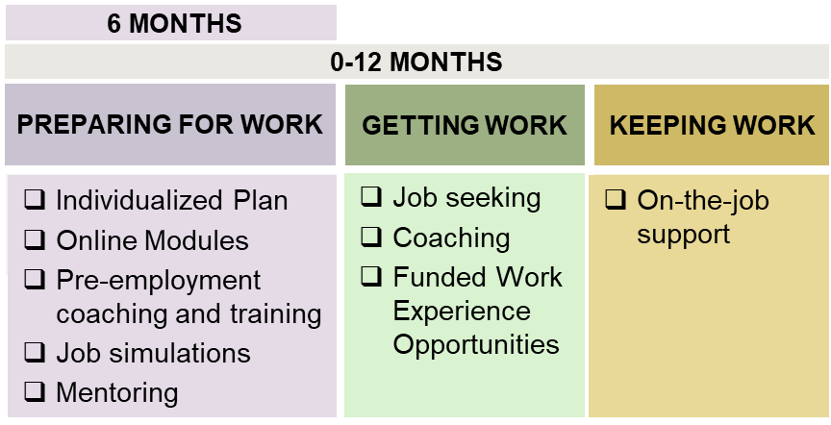
Participants are eligible to access services and supports for twelve months from their date of enrolment in the program. The EmploymentWorks program structure is intended to support job seekers that would be prepared and ready to seek competitive employment within six months of program start. All participants are expected to actively participate in the labour market during the program with the objective of getting a job and gaining paid work experience.

- SCOPE OF COLLABORATIVE OPPORTUNITIES AND DELIVERABLES
Service Providers supporting active job seekers that are interested in closely collaborating with Sinneave under the parameters of the EmploymentWorks Project will be expected to:
- Facilitate participant enrolment in the EmploymentWorks Online program according to Government of Canada requirements.
  - Eligible participants are individuals who self-identify as being Autistic, neurodivergent, or as a person with a disability, that are motivated to get a job within the next year and legally entitled to work in Canada.
- Facilitate participant access to relevant EmploymentWorks Online content and resources
  - Will require review of and familiarization with available content and resources to help guide participants to relevant resources based on their individualized needs.
- Assist participants with the completion of an Individualized Employment Action Plan (IEAP)
  - The purpose of the IEAP is to develop a structured plan and actionable steps for a participant to effectively navigate their employment readiness and to achieve their employment goals.
  - An IEAP template is attached as Schedule A.
  - Please note that participants are eligible for a $250 IEAP completion bonus
- Facilitate participant access to available job supports
  - Assist participants to identify job support needs, such as job coaching and/or workplace equipment or tools, and to submit request forms to EmploymentWorks national project staff through established processes following completion of an IEAP.
- Facilitate funded work experience opportunities for participants with employers
  - Support employers seeking talent by facilitating the hiring of participants into paid work experience opportunities. Employers are eligible to access reimbursement for up to 360 hours of work experience at local minimum wage.
- Complete participant reporting and quarterly reports as required through established processes.
- PROPOSAL CONTENT

The following information should be fully addressed in proposals:
- Provide a brief description of the current autism-serving employment program(s) and service(s) you currently offer and how you believe EmploymentWorks project content, resources and supports will be complementary and assist those you serve to get and keep jobs.
- Provide description of facilitation approach and/or staffing model expected to support proposed implementation of EmploymentWorks programming into current service offerings.
- Specify the number of participants that you seek to serve through the EmploymentWorks project between June 1, 2024 and March 15, 2026, as well as the funding requested to complete the deliverables outlined above on a cost per participant basis. Please note that funded job supports for participants and wage subsidies for employers are not included in the cost per participant for the purposes of your proposal. The cost per participant should not exceed $5,400. Details of how you calculated the cost per participant are required. (i.e., number of hours of service and hourly rate).
- A description of where within the province of Quebec that the proposed participants would be served (i.e. a specific municipality, one or more regions, etc.)
- Any added value the proponent brings to the project. Experience with content and resource development and / or job development and employer engagement considered an asset.

- SELECTION CRITERIA
Proposals will be evaluated based on the extent and relevance of experience, connection to active job seekers and quality of the proposal. The successful applicant(s) will have experience providing employment services and supports to Autistic or neurodivergent job seekers, engaging with employers and businesses, and supporting neuroinclusive work environments.

- SUBMISSION OF PROPOSALS
This request for proposals will remain OPEN until funding available through the project is fully committed. All proponents should submit their proposals in PDF format via email to Jessica Genato at jessica.genato@sinneavefoundation.org. Sinneave will respond to all proposals within seven days of receipt indicating next steps. Sinneave is open to considering alternative proposal formats, including a verbal presentation
- QUESTIONS AND INQUIRIES
All inquiries related to this Request for Proposals are to be directed to:
Jessica Genato, Executive Associate
The Sinneave Family Foundation
jessica.genato@sinneavefoundation.org

Any requests for access to the project content and resources (i.e. EmploymentWorks Online Program, EmploymentWorks Portal, etc.) to review and assess the applicability to jobseekers you support are to be directed to:
Ian Humphreys, Employment Advisor
The Sinneave Family Foundation
Ian.humphreys@sinneavefoundation.org

